QNS
Qn1
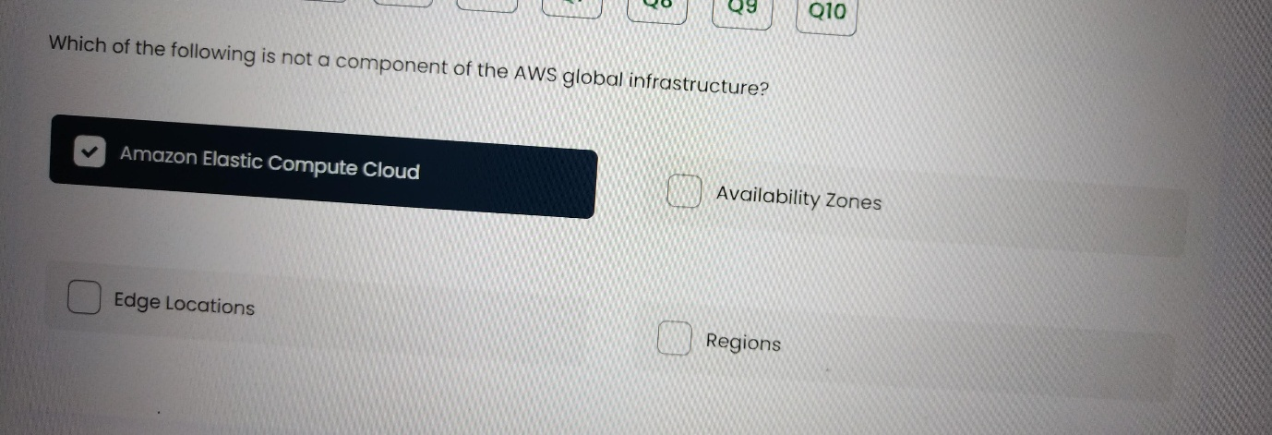
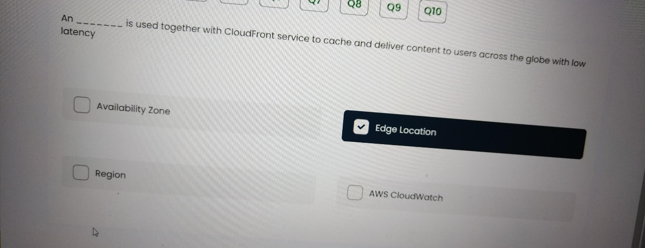

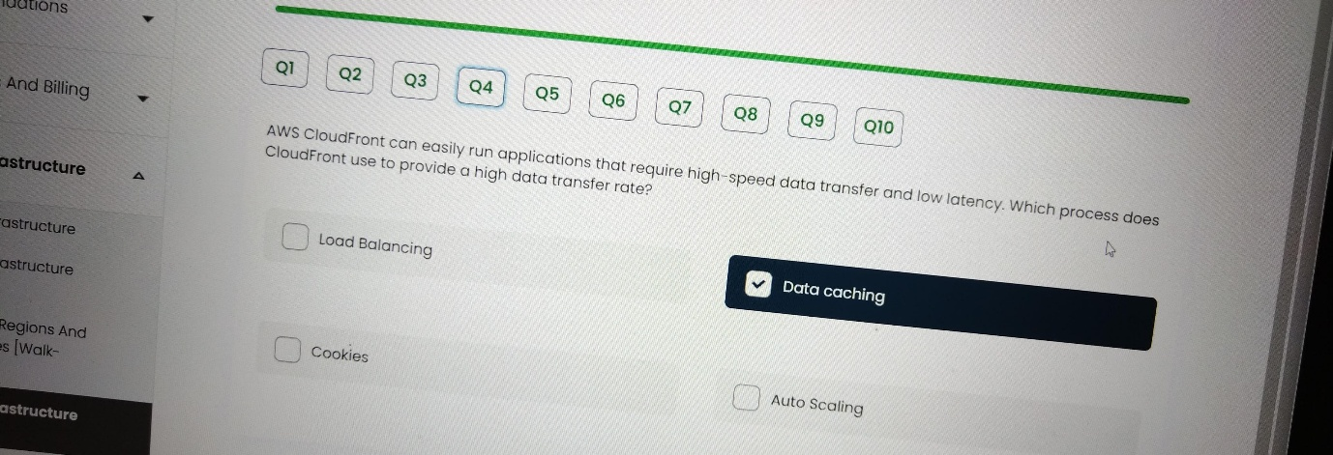
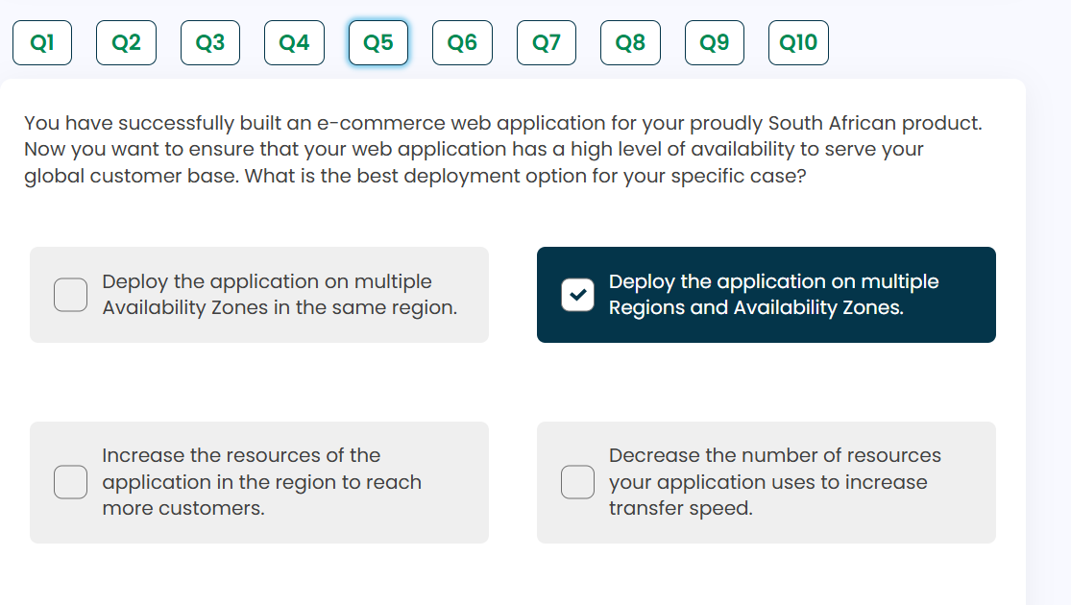

Which components of AWS global infrastructure ensure high availability and fault tolerance of the AWS resource you deploy?
- Availability Zone
- Amazon Elastic Compute Cloud
- Regions
- Edge
The combination of Availability Zones (i) and Regions (iii) are the key components of AWS global infrastructure that ensure high availability and fault tolerance of deployed AWS resources.
Availability Zones are physically separate data centers within a Region with independent power, cooling, and networking. This isolation allows you to deploy applications across multiple AZs to protect against failures in a single location.
Regions are geographic areas containing multiple Availability Zones. They are completely independent from other Regions, providing fault isolation at a geographic level for your applications.
Amazon Elastic Compute Cloud (EC2) is a compute service, not an infrastructure component focused on high availability. Edge Locations are primarily used for content delivery and DNS services, not for general resource high availability.
Therefore, the correct answer is: i & iii (Availability Zones and Regions)

